Pete Hendrickson’s List of Opinion Leaders w/emails
Name/Organization | Twitter | Email, etc.
Glenn Greenwald | @ggreenwald | glenn.greenwald@theintercept.com
Lew Rockwell | @lewrockwell | lew@lewrockwell.com
Tom Woods | @ThomasEWoods | woods@mises.org
Thomas DiLorenzo | [?] | TDilo@aol.com
Chuck Baldwin | @drchuckbaldwin | chuck@chuckbaldwinlive.com
John Whitehead | @JohnW_Whitehead | johnw@rutherford.org
William Anderson | @WillWVNN | anderwl1953@yahoo.com
Justin Raimondo | @JustinRaimondo | justin@antiwar.com
Karen Kwiatkowski | @karen4the6th | ksusiek@shentel.net
Paul Rosenberg | @rosenberg | p.rosenberg@cryptohippie.com
Tom Englehardt | @TomDispatch | tomdispatch@yahoo.com
Laura Poitras | @citizenfour | laura.poitras@theintercept.com
John Stossel | @JohnStossel | john.stossel@foxnews.com
KrisAnne Hall | @KrisAnneHall | thepastorjchall@gmail.com
Robert Parry | @Consortiumnews | consortnew@aol.com
Paul Craig Roberts | @PCraigRoberts | instituteforpe@gmail.com
George Noory | @George_Noory | george@coasttocoastam.com
Jonathan Turley | @JonathanTurley | jturley@law.gwu.edu
G. Edward Griffin | @G_EdwardGriffin | griffin@realityzone.com
Doug Owen | @BLNRadio | doug@oraclebroadcasting.com
Alan Watt | [?] | alanwattcuttingthrough@yahoo.com
Alex Newman | @ALEXNEWMAN_JOU | alexnewman_85@hotmail.com
Adam Kokesh | @adamkokesh | adam@adamvstheman.com
Janet Phelan | @ActivistPost | writejanet@live.com
Pat Shannon | @TuMalditoGringo | shannanpat@gmail.com
Robert Higgs | @IndependentInst | rhiggs@independent.org
Sharyl Attkisson | @SharylAttkisson | info@sharylattkisson.com
Gerald Celente | @TrendsJournal | gerald@trendsresearch.com
James Corbett | @corbettreport | james@corbettreport.com
Jeff Rense | @RenseRadio | jeff@rense.com
John | @JohnBWellsCTM | john@caravantomidnight.com
Leland Conway | @LelandShow | leland@whas.com
Melissa | @truthstreamnews | melissa@truthstreammedia.com
John Odermatt | @LionsofLiberty | felonyfriday@lionsofliberty.com
Christopher Bollyn | [?] | bollyn.books@yahoo.com
Katherine Hine | [?] | katherinehine@wljaradio.net
Radley Balko | @radleybalko | radleybalko1@gmail.com
Andy Ostrowski | @AndyOstrowski | ajo@bsolaw.com
Jon Rappoport | @jonrappoport | qjrpress@gmail.com
Marti | [? Webhttps://ppjg.me/] | ppj1@hush.com
Jenna McLaughlin | @JennaMC_Laugh | jenna.mclaughlin@theintercept.com
L. Neil Smith | @ElNeilSmith | lneil@netzero.com

Other List(s)
You can build other lists using the same technique, esp. a list for state activists, media people, liberty advocates, for local political activities to give notice and round up the troops. Also a personal list for friends and acquaintances who are on Twitter.

Brian Wright’s List of National Opinion Leaders, Twitter Addresses
Name/Organization | Twitter | Email, etc.
Brian Wright | @brian_r_wright
Abby Martin | @AbbyMartin
Alex Jones | @RealAlexJones
Alison Weir, If Americans Knew | @ifamericansknew
Alli Mou | @humankindness5
AlterNet | @AlterNet
Ann Coulter | @AnnCoulter
Ari Armstrong | @ariarmstrong
Barb Loe, NVIC | @NVICLoeDown
Blacklisted News | @BlacklistedNews
BORDC | @BORDC
Breitbart News | @BreitbartNews
Connie Gallippi | @conniegallippi
CounterPunch | @NatCounterPunch
Cynthia McKinney | @cynthiamckinney
Dane Wigington | @RealGeoEngWatch
David Icke | @davidicke
David Knight | @libertytarian
Downsize DC | @DownsizeDC
Edward Snowden | @Snowden
Elizabeth McCauley | @etmccauley
FederalJack | @FederalJack
FEE | @feeonline
FFF | @FutureofFreedom
GEORGE MEEGAN | @GEORGEMEEGAN
Global Research | @CRG_CRM
Intellihub | @intellihubnews
J. Neil Schulman | @jneilschulman
Jacob Hornberger | @JacobHornberger
Jeffrey A Tucker | @jeffreyatucker
JewishVoiceForPeace | @jvplive
Jim Babka | @JimBabka
Jim Rickards | @JamesGRickards
Joe Catron | @jncatron
John Kiriakou | @JohnKiriakou
John Pilger | @johnpilger
Jordan Page | @JordanPageMusic
Kevin Barrett | @truthjihad
Lee Ann McAdoo | @LeeAnnMcAdoo
Libertarian Papers | @libertarianpprs
Liberty Conservative | @LibertyConserv
Lost Horizons/Pete Hendrickson | @losthorizons1
Luke Rudkowski | @Lukewearechange
Mark Dice | @MarkDice
Mary Ruwart | @ruwart
Mises Institute | @mises
Nick Gillespie | @nickgillespie
Objective Standard | @TheObjStd
Patrick Heller | @libertyfrandor
Paul Jacob | @pauljacob
Perry Willis | @PerryWWillis
Peter Schiff | @PeterSchiff
Rand Paul | @DrRandPaul
Ray McGovern | @raymcgovern
Reason Magazine | @reason
Richard Gage, AIA | @rgage33
Richie Allen Show | @RichieAllenShow
Rob Dew | @DewsNewz
Roger Stone | @RogerJStoneJr
Ron Paul | @RonPaul
RT America | @RT_America
Scotty Boman | @boman2012
Sheldon Richman | @SheldonRichman
Sheriff Richard Mack | @SheriffMack
Sibel Edmonds | @sibeledmonds
Stanley Cohen | @StanleyCohenLaw
Stefan Molyneux | @StefanMolyneux
Stone Cold Truth | @StoneColdTruth
Tatiana Moroz | @queentatiana
The Rutherford Inst. | @Rutherford_Inst
TheNewAmerican | @NewAmericanMag
Thomas Drake | @Thomas_Drake1
Thomas H Greco Jr | @tomazgreco
Truthout | @truthout
Webster Tarpley | @WebsterGTarpley
Wendy McElroy | @WendyMcElroy1
WikiLeaks | @wikileaks

Important Tweets
Here it’s a good idea to place your basic Tweet messages and images, also the ‘shortcodes’ that you can use to insert conveniently into individual Tweets and emails, etc. I’m including my own first two, one for a big 9/11 event and the one for CtC where I’ve added a graphic with textual info.

1:
Rudy Dent, 9/11 FDNY 911Truth Hero: watershed video: Barrett, Gage, Bollyn in Detroit 2/19/17 https://www.youtube.com/watch?v=kIWBvg4AX2A&feature=youtu.be&t=69
Attaching Image:
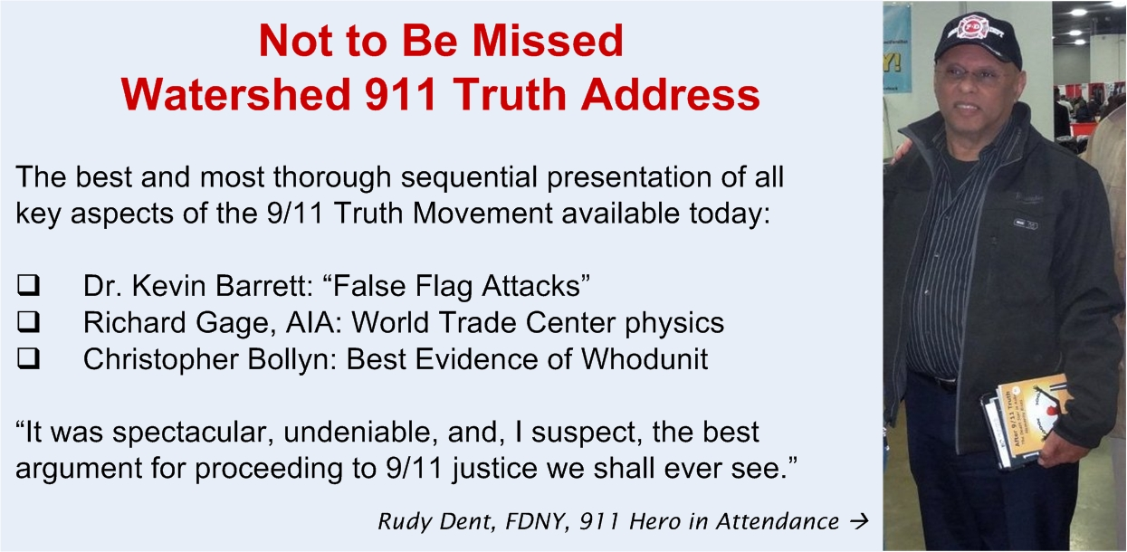
Shortcode (use in email messages, also to Tweet individually)
https://twitter.com/Brian_R_Wright/status/837386379994742784

2:
A real opp this year to rein in the federales by drying the wells of incorrectly extracted wealth. http://losthorizons.com/A/HowTheBeastGetsItsDinner.htm
Attaching Image:

Shortcode (use in email messages, also to Tweet individually)
https://twitter.com/Brian_R_Wright/status/837457182715183104

3:

