Free State PorcFest 4 (2007)
The Free State in summer
The Free State Project (FSP) Porcupine Festivals have been three in number thus far: 2004, 2005, and 2006; and they've been summer events in scenic northern New Hampshire campgrounds to keep costs down. In 2007 we decided to add a winter event which I covered here, but to keep the summer event more or less intact.
We moved the summer 2007 Porcupine Festival to a campground closer to the lower 48, and Honorable Rich Goldman stepped up to be Czar or Head Ramrod, what have you. Once again I can't resist the need to diarize the proceedings, tho I'm going to attempt to be briefer this year... you know, leave some things out. Everyone should just come here personally to experience the fabulous reality first hand.

Transit To, June 20, 21
These days, like a few others committed to the Free State concept, I have one foot in New Hampshire and one foot still occupying a center of life back in the VAW (Vast Authoritarian Wasteland)... which happens to be SE Michigan in my case.
I've made the trek to and fro several times now. I believe I could get frequent-driver points if ExxonMobil or BP were ever to put forth a marketing program along those lines.
Though you can drive Michigan-to-Free-State in a day, it's 15 hours. So I normally do an overnight, midway; the Knight's Inn in Liverpool, near Syracuse, NY, has reasonable rates ($50-something per night), microwave, small refrig, fast Internet, hot babes... just making sure you're awake.
This year, I reached the Inn early, so I was curious if any brew pubs were nearby. The check-in lady says, "Sure, go down to Syracuse, the famous Armory Square area, and party with the college kids." Sure enough it's a happenin' urban street scene, people all over the place. Parking is high; I settle for a lot at $4 for a minimum of five hours. Yikes!
Walking around, I'm looking for the brew pub she told me about, but I can't remember the name. I do see a red neon sign Empire Brewing Company, then hoof it down a short flight of concrete steps: Voila! Brew Pub! The bad news is it doesn't have its liquor license yet; the good news is they'll give you as many sample glasses of whatever style you want as long as you're dining. :)
Good banter with the bartender, Jeff, and John another fella there; apparently the license was applied for three months ago and they're still waiting. Here's my plug for a very cool, even elegant, not-too-pricey brew pub coming online eventually: friendly people, GREAT food. (Their proprietary Mojo mustard makes a good hors d'oeuvre by itself.

Empire Brewing Company
120 Walton St.
Syracuse 13202
315-475-BEER.
Drive across New York next day, nothing eventful, except I'm listening to this audio CD "The Secret" given to me by a friend. It's about four hours long, and the message is that positive thinking is good for you. Wouldn't it be nice to integrate a life of wealth and happiness with social justice? (Here's my post of the review.)
Once again, when I reach the NH town of New Boston I get my special Kim Cahill haircut for wannabe good-looking guys on the move. Then I arrange for accommodations. I can crash at my digs in Amherst, but the furnishings are going to be nonexistent. I elect instead to stay down the street at the HillBrook Motel in Bedford. Reasonable rates, microwave, small refrig, fast Internet, catering to NASCAR elites(?).

Day 1: Friday, June 22
Motoring to the Gunstock Mountain Resort in Gilford I stay off the EWays, keep to NH 28 and NH 107; I'm actually rather proud of myself for managing to stay, in New Hampshire (!), on the particular highways I had planned to be on. Here's one of those commonly seen DeLorme map consultations by the side of the road where I stop to make sure I'm heading in the right direction on HW 107.
It's turning out to be cooler than expected. I'm wondering if my Hawaiian shirt and sandal ensemble will cut the mustard during my two-night occupancy in tent city at the lodge. Maybe I can lease an innovative space heater that runs on surplus flatulence.
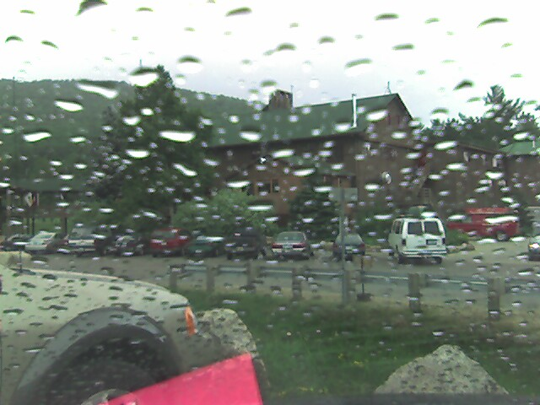
Check in is routine, I get the lay of the land relatively quickly. Gunstock is different from the Rogers Campground where we stayed previous summers. It's larger and more spread out. Also a bit strange: you drive onto this enormous expanse of unpaved parking lot where you have to circle all the way back around to get to the gate to the camping areas. No rhyme nor reason as to what's paved, but when in doubt they leave it (the paving) out; it's harsh on my well-worn tires. The photo at right captures my grand entrance.
The lodge area is fully enclosed, shielding us from the elements. It holds the floorspace for speakers and assorted literature tables on the circumference. Some lit tables are arrayed on the balcony, where I have one, and it looks like a couple of side rooms are available for conferences. You can probably seat 300 or more people, with some additional standing room.
After setting up my books and bumper stickers, etc., I drive back to the campsite—I don't measure it, but I think it's 3/8 of a mile or so, not easily hoofed at my advanced age—where I improve the neighborhood with a fine temporary home. Shown on the right is my ad hoc Survivor handicraft. Note, my tent is the identical brand and model to the one next door.
Turns out the people staying in the other tent are an interesting bunch of first-timers: a mother from Oklahoma and her son and daughter. The son is the intentful Free State member, and the daughter lives in Mass. So Mama Bear uses her daughterly visit to bring all of them to the Porc Fest. They're the Hensches, I believe I got the name right, and her quiet, warm intelligence reminds me of my finest acquaintances in the Sooner State..
I head back to the lodge where the reacquaintances have begun. A presidential debate is in progress and I'm going to have to make a negative observation: Just because you're photogenic, you're honest, and your friends down at the diner swoon over your rhetorical skills, you don't need to seek the Libertarian Party (LP) presidential nomination.
With the exception of legitimate frontrunner George Phillies, a physics professor from Worcester Polytechnic Institute, each of the LP wannabes seem to think global warming is a myth by evil liberals who want to stick us with big one-world government. Ironically, two candidates propose government programs for education and health care, respectively.
Later, in line for dinner, I speak with one of the Hinterland candidates, Richard Smith of Texas. He's a good ol' boy, truly a nice man, who believe it or not thinks we can win in Iraq. "How," I ask, "by bombing them back to the Stone Age? They're already there." He truly hasn't considered, for example, that the Iraq war was premeditated by some powerful men quite uninterested in reason, freedom, or a positive outcome for us humans.
Sorry guys, you simply have do some reading... and start by checking out the LP Platform, still a marvelous document and economical statement of political morality (though it needs an environmental plank).
The festival has run since Monday the 18th, including hikes; tours; freedom discussion forums; mock town hall meetings; pub gatherings; scuba diving; games: volleyball, badminton, wiffleball, horseshoes, kickball, dodgeball; Objectivists' Meetup; campfires, beer, and movies in the outdoors; Frisbee, gun owners meetings, and a candlelight vigil for Ed and Elaine Brown. But most of the attendees, like me, are only here for today, Saturday, and Sunday.
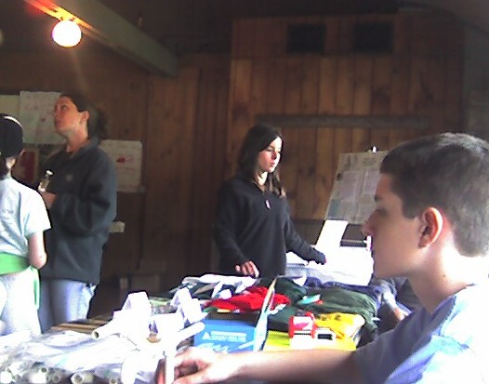
The main business activities I'm up for are presentations and discussions, but because I have a table my principal job is to either sit and chat or wander around and chat, which means basically to be in "hang mode." The photo here shows the paraphernalia table set up by the ubiquitous Chris Lawless (Dreepa). The younger person in the foreground is none other than Stupendous Man "Defender of Freedom, Advocate of Liberty" marketing his ingenious home-schooling enterprise Marshmallow Gun Kit. (What's most ingenious is how he can mark it up to $10; naturally I have to buy one.)
As for setting up in hang mode, ah, the pleasures of being irresponsible! (I do have a presentation on my Sacred Nonaggression Principle tomorrow.) And I do plan to elevate myself into star mode—or at least buzz mode—at the liberty campfire events later tonite and tomorrow nite.
Before tonite's big finale, let me mention two ageless gentlemen who stop for some hang time at my table, one, Mr. Gaylord Nelson, of 60+ years, the other, Mr. Neal Connor, a mere 20.
Gaylord is a retired engineer and inventor who has read the previews of my book where I mention the idea of sustainable energy. He seems genuinely interested in talking to me about what I know of alternative energy technology. I have to confess my engineering degree is so old they could use it in a Rustoleum commercial. He has some patents and I don't want to seem unkind; I just don't understand how I can be of much help now. I network him over to Jack Shimek at Alternative Expo.
Neal Connor, on the other hand, comes from the Boy Wonder side of the political spectrum. Holstering a chrome-plated revolver of some brand he could be the reincarnation of Ricky Nelson in Rio Bravo, The Colorado Kid. He's certainly a top gunslinger of ideas, as we talk about everything from the abject betrayal of rationality by henchmen of the Ayn Rand Institute to my review of Ray Kurzweil's book on radical life extension.
Neal is also a Gator (University of Florida student), president of the Libertarian Activist Network there, and chairman of the LP of Alachua County, wherever that is.
He seems to be one of those rare readers that appreciates my original version of New Pilgrim Chronicles more than I do. "You mean you don't think I was too hard on the Christians and people of faith in there?" I ask. He says, "You were giving your opinions, isn't that what we're supposed to do? I think it reads well and makes sense."
Bless you my son. Live long and prosper.
###
The buildup for the Circle of Liberty Campfire at the Boardwalk area has me all excited, except I have no idea where The Boardwalk is. I check out this broad open field that has a small army of tents perched everywhere. I wander around like a homeless man with a bag containing bottles of brewski, walking to campsite after campsite, anywhere I see a fire. No dice; this one here is some kind of man/boy event... are the Promise Keepers still in business?
I'm about to give up but as I head back toward my own camping area I vaguely make out a group of young freedom people, evidently in happy suds-and-buds mode, i.e. looking to party. They're also seeking the Boardwalk and the campfire doin's. "Jointly," we come up with a high-level, detailed strategy to "go over that (pointing) way."
It's cold and I only have the two beers. I'm not in that much of a conversational mood; the campfire is happnin' but I don't see people I recognize. Very little moon. The Boardwalk is a football-field-sized expanse of flatland with some tents and trailers scattered on the periphery. At one end, they've thrown up a screen, with a projector hooked to a DVD player, brightly displaying The Fountainhead.
Here's the Boardwalk area in daylight:
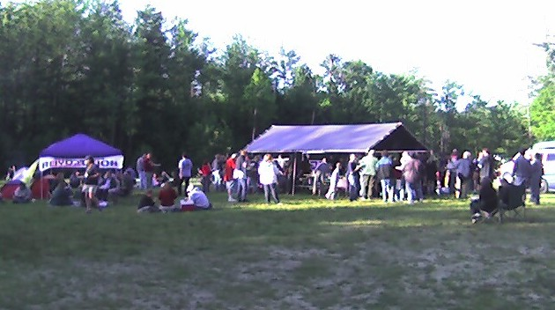
It's reasonably early in the movie. People are scattered around sitting on picnic tables and a few folding chairs; I stand for a while, pop a top, then watch evening-gown-clad Dominique Francon (the beautiful Patricia Neal) tell Howard Roark (Gary Cooper) she has to destroy him for being so good... but first let's field test the architecture of your bedroom. All satire aside, I still love this movie and the unique passion of Ayn Rand breathing, heavily, within it.
But I'm tired and The Fountainhead by the campfire light is more surrealism than I can handle at this late hour. I leave where Ellsworth Toohey—has any author in history had a better knack for names—is telling Peter Keating that Peter is a third-rate imposter and would not know the first thing about designing affordable low-income housing. Harsh; you can see why Peter has such sniveling low self-esteem.
That's my cue to return to my own low-income housing for the weekend, wherein I crash gratefully for the night.

Saturday, June 23
I awake in my tent thinking I need to talk to the landlord about the heating system. The outdoor temperatures we were told would be dropping into the 40s, and the indoor temperatures didn't climb much above that. Cold and stiff from lying on this cot all night, I manage to rise and make my way toward the bathroom.
I don't want to be negative, so let me just say the facilities are much better than if you were to string three outhouses together—with more privacy, though not as much elbow room, than the Harris County Jail (Houston). I don't see any urinals (so the toiletry can be used coed I surmise) but two small shower stalls, a row of crappers, and I never cared to know what was behind Door Number 2. Then three sinks crowded together and a mirror, as I recall.
Because of the cramped quarters and lack of things like shelves, hooks, benches, space, I decide I'll forgo showering for a couple of days and rely on an extra layer of deodorant to keep the hot babes from running off screaming. And I'll brush my teeth regularly, too.
This is the main day of the festival, but unlike previous years, no Jason (Jason Sorens, the founder of the Free State Project) and no Amanda (Amanda Phillips, she's been FSP director, and I've always considered her one of the leading ladies in the Free State drama, kind of a Dagny Taggart VP of Operations qua Toastmistress).
I remember well the first Porc Fest in 2004. What a thrill! Not only because it was my first time, but because it was everyone's first time. Jason and Amanda did a tag-team revelation-and-enthusiasm routine at the podium that raised the roof; you could feel the energy pulsing through the presentation area... like an old-time revival tent. We were there to save and be saved. We felt the excitement of beginning an earthshaking journey of deliverance.
Now the journey is well underway, and some would say we (i.e. the FSP organization) stand at a crossroads. It seems we now need to cross a chasm of cultural lethargy if we are to reach anything like the originally defined destination. From my perspective now, there's the Free State Project (FSP) and the Free State Movement (FSM)—the movement being defined by actions of the early movers in concert with the pro-liberty efforts of preexisting New Hampshirites already in progress.
Bespeaking the FSM, several of these early movers tell their stories in the We've Made the Move Panel discussion shown above. Of course I have my own early mover story, and I know most of them on the panel, especially Brad and Margot Keyes who came with their four girls from Minnesota a year before I did, doncha know, eh.
Indeed, just as I see Justin and Amanda as fountainheads of the FSP, I view the Keyes as poster children of the FSM. I'm not saying they're Ward and June Cleaver or anything; only if we ever put together a movie showing how so many attractive, normal family people are coming to New Hampshire to work for more freedom and to enjoy more quality of life in general, I'd give the Keyes star billing.
In the afternoon, early movers defined as part of the First 1000 assemble for a group photo. It looks like about 100 of the the 475 reported to have moved are on hand and it's a jovial, lively crew for sure. I'm in there somewhere but the pixel sparseness makes it hard to see the especially good looking guys.
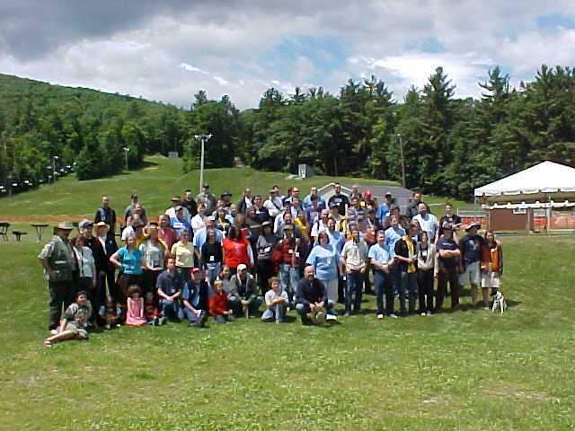
The rest of the day is taken up by workshops and discussions on everything from NH Information and Jobs, Building a Website, Fundraising, and Recruitment to "Right Libertarians" (I have an image of heavily armed fetuses with W stickers on their butts patrolling the Mexican border and refusing to file 1040s) and Time Management. Somewhere in here the vendors and exhibitors get the opportunity to introduce themselves.
I put in my two cents for New Pilgrim Chronicles, but it's so soft sell I'm afraid some in the audience are put off by it. Damn, I need an agent! A promoter. Maybe the FSP needs someone(s) like that, too. We're rich in idea types, computer jockeys, scientists, engineers, left-brainers, what does the Kiersey data show: 90% of the libertarian movement is "NT" (intuitive-thinker) compared to 10% of the general population?
Anyway, jumping ahead to tomorrow and a conversation with John Fitzpatrick, John said something to
the effect, "We have volunteer wizards who can design Websites, organize political action, write sophisticated analyses, even maintain databases and ramrod successful conventions, but do we really have any sales and marketing stars?" And I'm thinking if any are interested in promoting the FSP/M, are we willing to pay the freight?
I'm going to stake out a link here for my own thoughts on the general issues confronting the FSP/M in terms of "crossing the chasm," then soon I hope offer a modest proposal. Such will be in the nature of friendly amendments: I remain a stolid panegyrist for the organization and for the movement and I have nothing but the utmost respect for its head ramrods and volunteer wizards.
As for my own promotional needs, I'm thinking next year I'll bring in some dancing bears.
Before tonight's renewed festivities, it's my turn to chat with the Altexpo folks, giving a presentation: "Additional Comments on Cutting the Gordian Knot of Oppression with the Sacred Nonaggression Principle." Jack Shimek has been the prime mover of getting the alternatives— alternative energy, food, transportation, institutions, and so on—people together. As the final presenter, I'm basically taking part in a rap session with half a dozen of the most steadfast of the Mohicans. Good feedback all around.
Tonight is the cook off, also being held at the Boardwalk. (Last year at Rogers Campground the cookoff was more chili-focused, and everyone cooking was also camping within the same neighborhood.) This year we have fewer entries and a variation of dishes... including it seems a preponderance of shrimp, to which I'm allergic, or seafood combinations. But for my $10 fee I have no complaints on the remaining cuisine.
I need to leave and change into a clean sweatshirt before coming back for our final "Burning Man" campfire, cocktail party, and socioideological adventure. Before disconnecting, I run into Steve Goodale, probably one of the most generally knowledgeable individuals I've met on the "occult technology of power" and its recent excesses in orchestrating the 911 attacks and furthering the Cartel's imperial designs. He gives me a couple of DVDs and I buy a book, in fact, a fascinating discovery I'll be reviewing soon: Truth Jihad, by courageous 911 scholar Kevin Barrett.
Later at the soiree I see former roommate, peace and personal-freedom Free State activist Matt Simon. There is none higher—well, he's 6'4"—so damned easy to spot among the crowd. I'm giving him a plug for his NH Common Sense work to decrim cannabis, so please click on the image on the left and send money. We manage to locate an untapped source of Smutty Nose IPA (very good beer) that one of the Altexpo fans has brought. Soon Matt wanders off presumably on a mission of virgin conversion or some such, but I feel like I've found my home for the evening. I make a small contribution to the beer kitty and proceed into friendly buzz mode. I'm really beginning to sound brilliant, and so are these other guys, when I decide I should make a pass by the campfire to see who's who.
This tiny oriental woman looks interesting. I introduce myself fighting the impulse to get down on my knees so I'll be on the same eye level. Her name's Le Trans (Trans Le(?), I resolve to remember, but my best name-recalling brain cells have just died). What she lacks in physical stature she more than makes up for in intellectual presence. She's from Vietnam, originally, living in the Boston area and helping to lead an neo-Objectivist group with Amanda Phillips.
We're getting into some arcane Ayn Rand back-and-forth when young Neal Conner—the Gator Kid with his .45—shows up and chimes in. (Funny how an attractive young woman with strong opinions gathers men like moths to a flame.) Nor is Neal, as we've learned from Day 1, any slouch in these matters of Rand or related. The specialized cause-oriented banter among the three of us is quite stimulating, yet I'm reaching saturation... on the intellectual stuff, too.
Another day in the hopper, I meander forthrightly back to my side of the tracks of the Greater Gunstock metro area eager to see whether I'll survive another night without frostbite. No worries, earlier I bought a blanket from the commissary.

Day 3: Sunday, June 24
Back at Rogers, on getaway-day a.m., we atheists would vie for whether we could bring more people together for deep spiritual discussion in the woods than the Christians using the presentation hall. (Just kidding; Amanda would lead the discussion and we'd agree with her not to gloat over favorable comparisons to the others... but we won, we won! Whoops.)
Anyway, I don't like to use the word atheist, except to mean a refusal to accept conventional theistic notions or "definitions" of supernatural-Jesus Christianity. As Sam Harris puts it in Letter to a Christian Nation:
"...atheism, is a term that should not even exist. No one ever needs to identify himself as a 'non-astrologer' or a 'non-alchemist.' We do not have words for people who doubt that Elvis is still alive or that aliens have traversed the galaxy to molest ranchers and their cattle." — pg. 51
This year Reverend Garrett Lear leads the service for the supernatural-Jesus people while Jack Shimek and his Seekers group welcome, if not represent, the atheists as best they can I guess. I don't know, since I don't disconnect soon enough from my breakfast reverie and discussion at the Lodge. I fall into a really interesting confab with John Fitzpatrick and another gentleman whose name I don't recall—got his card but somehow it failed to make the trip back to Michigan, AW (Authoritarian Wasteland).
Anyway, John has a fascinating background in alternative energy systems, acting, writing, and I believe he said photography or journalism. He's working on an innovative tool to market to energy companies that want to climb on the clean, carbon-free energy bandwagon... which sounded something like guerilla-theater public relations. Serious avant-garde material that may bring in some serious ducats.
Then the three of us kind of batted some ideas back and forth—actually I mostly just listened and asked questions—in connection with what we see as good things for the FSP/FSM to be doing going forward.
I've mentioned above that John expressed a desire to see more of a marketing focus. Either he or someone else this weekend had pointed out that on the floor yesterday, someone had said to a speaker, "We came to see about the FSP and nothing we've seen here makes us gung ho. Is this the best you can do to sell us on the concept?" Now he could have been some sour grape I've read on the forums who wishes the Free State were Wyoming or Podunk, but I don't think so. Could be a real issue.
I mentioned the excitement factor wasn't so high this year as I feel we truly missed the dynamic duo, Jason—Jason is like Clark Kent, you can tell there's a dynamo surging beneath the low-key professorial demeanor—and Amanda. Maybe the honeymoon is naturally over and we have to work now at keeping the love fresh and new. Or maybe it's time to start dating other people or seeking professional help.
If we go the direction of breaking out of the high-school cheerleader-carwash mode—by the way, there's much to be said for this approach—to reach the next level of financial status using "professional help," there will be other challenges. My experience with political organizations, including the Libertarian Party, is money tends to make the internal politics more volatile and unstable.
Personally, though, I think we have to do it, break the shackles of our comfort factor and step onto the world stage in a powerful way. (None of this to imply the leadership we have is ineffective.) We are already a success; we simply urgently need to be a huge success.
Perhaps the Ron Paul campaign will be a sea that lifts all boats. It seems every piece of news I get these days from the Ron Paul people—on 7/8/07 Dr. Paul had a very good interview with ABC's "This Week with George Stephanopoulos," and a communique this morning tells me Ron Paul has 20,000+ YouTube subscribers (Barack Obama has 8,800) and 20,000 Meetup group members—is majorly positive. (Pls. ref. to my column Ron Paul Nation.)
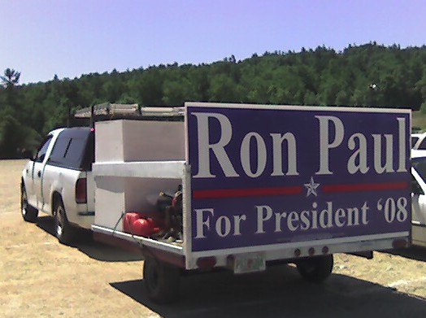
There's sure a ton of Ron Paul REVOLUTIONaries here this weekend! I get a kick out of this lawn landscaper's vehicle on the right. Speaking of grass roots activism!
Sorry.
###
This is the Sunday getaway day, but I'm not going too far. I circle back toward the Boardwalk where I briefly help the altexpo folks with breaking down their gear. A longtime liberty stalwart Don Quixote (I'm never sure whether I should use real names) can use a ride back to Merrimack which is sort of on my way to my Bedford staging motel.
The local popos have slapped Don around pretty hard, first a rogue oinker lying under oath regarding Don's failure to stop for a school bus. They take away his license, he drives anyway, they pull him over, and some dictatorial judge sentences him to six months in jail for the disobedience factor. What is it with these cops, prosecutors, and judges? Where's V for Vendetta when you need it?
Anyhow, the gentleman-victim being from Michigan originally, we have a lot to talk about and miles to do it in. It's a beautiful day for driving, we stop for lunch and a brew at a Mom and Pop biker bar in Manchester. Don is another Free State friend—been in NH for several years before FSP—who's a genuine fan of my New Pilgrim Chronicles (says he gave it to his sister to read: "This explains why I'm here and why I'm doing these things."). No way I'm charging such a discriminating reader for gas... or for the cleaning bill on the stain his bicycle chain imparted to my shirt as we shoehorned it into the trunk.
By the time I reach the motel, I'm whipped. No liberty campfires or other social-life pinnacles for the Freedom Rider tonight. Just a quiet evening to put the finishing touches on my second "golf in the provinces" column .
And so the fourth annual Free State Project Porcupine Festival draws to a close with a good deed rather than a round of golf. What did we accomplish? I'll save that for the next few days and the long spell of drive time back to MAW (Michigan, Authoritarian Wasteland).

Transit Fro: June 25-28
Though still a bona fide Free Stater, early mover, First 1000, etc., my living circumstances require me to hang back in the MAW for a few months. I maintain the FS pedigree and the legal paraphernalia (driver's license, car registration, voter's registration, etc.) with my residence in Amherst. I've allotted Monday and possibly Tuesday for updating my stuff.
NH as many know requires an inspection sticker before you can legally put your car on the road; I've done this before. After visiting my friendly Amherst town clerk and paying umpty-ump dollars for the privilege of operating a motor vehicle on the state's roadways, I drive to my favorite antique Union 76 gas station in New Boston to schedule the checkup.
Note: I also get my voter's registration squared away—I will declare as Republican for the primary so I can be part of the Ron Paul landslide in January or February (exact date yet unknown)—and ask regarding the procedures for voting absentee if I need to do that.
Union 76 can't get to the inspection today, so I schedule it for tomorrow. In the meantime, my left rear tire has been losing air since the trip back from Gunstock, probably from sharp-rock overexposure. I ask if they can repair it but they're not so equipped. The full-serve attendant, who reminds me of
Noah Berry, Jr. (Jim Rockford's father in The Rockford Files), says, "You go down this road 3.8 miles and take a left at the bridge—not the 4.0-mile crossing at the horse barn—drive over the bridge and veer to your right. Go north for about a mile and a half, where you'll come to the Goffstown highway (the highways have numbers but the locals either don't know the numbers or don't believe in them). Turn left and find McGee's on your right less than a quarter mile down. Best tire place around."
Sure enough, McGee's is a fine place. This fits right in with my "support your local independent business" philosophy. They take their time but do it right. I remember shooting the breeze with the 18-something tire tech, give him a tip and one of my cards, tell him about the Free State. He's happy to hear about it, even though he probably doesn't care to spend time for anything political.
It's just an impression I have from several encounters with the blue-collar youth of America here. They're different from AW youth. It's subtle. They're courteous, bright, quiet but glad to converse briefly, probably raise hell when the time is right, and have a lot of pride in just doing whatever it is they're being paid to do, and doing it right. You also sense they have a finely tuned BS extractor and don't take abuse from anyone. For these reasons they exude a well-earned self-confidence if not superiority. It's great: shock troops of the revolution.
In fact, they seem to have the general temperament of our man-on-the-street hero Joel Winters, a freedom VIP all star and most valuable player in the NH General Assembly. Good work on Real ID, JW!
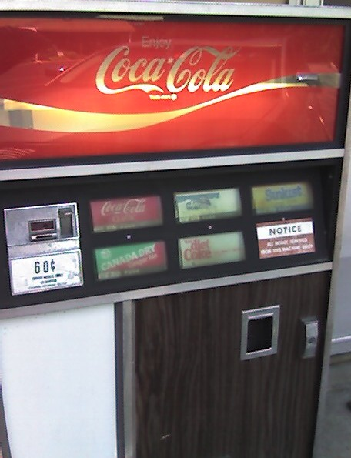
The afternoon I spend back in the air-conditioned comfort of the motel, writing my review for the audio book I listened to in my car on the way over, The Secret. (Note, the motel Coke machine with 60-cent Cokes!) This is a motivational work, and apropos for some thinking I've been doing on applying motivational principles to the freedom movement. I visit my favorite Thai restaurant in Manchester for dinner, then come back, write, read, chill, and crash.
###
On Tuesday the 26th, it's up to New Boston again for the car inspection. I know there are probably closer places, but this is my third one and they've all been at the NB Union 76. Tradition. I'm anxious that I might need to get some repairs on account of the "Check Engine" light displays frequently. Often that's emissions related, and the diagnostics especially make sure you're under control on the air-pollution front.
Nope, good to go. That'll be $40. Bob advises me to get my coolant flushed; that may be the reason the light comes on. He also tells me I can't legally put those clear plastic covers over my license plate. I have one on the rear plate mainly for esthetic reasons. "The state doesn't care about art; they'll ticket you because it interferes with their toll booth cameras."
That does it for all the business reasons I have to stick around; I was going to see if Matt Simon and/or Shuvom were interested in golf, but they're back in 9-to-5 mode so to speak. Later, I was hoping Matt could join me for dinner at one of our finest-dining finds, Buckley's Steak House in Merrimack. But no dice; activism overload... "What's her name, Matt?"
So I motor down to the steak house by myself, take a seat in the bar. I order one of their special martinis then a steak salad. I'm making pretty good culinary progress when lo and behold, who walks in but Shuvom Shuvom! Turns out he's never been here, it's simply on the way home from a long day in Mass setting up engineering training.
Fabulous. I really haven't talked with Shuvom for any length of time, and as most freedom people he's a source of ideas you don't often run into. Plus, Shuvom is a live wire, always cheerful, positive, wanting to do things. Think of extreme sports: "Let's make up signs and get a squadron of hang gliders to land on the Capitol lawn!" Then unless he gets redirected he'll assemble the equipment, have the signs made, and phone 100 people within the hour.
Fortunately for me, he's a little more subdued tonight. I manage to get an idea of where he went to school, how he came to be an early mover, what's shaking in the engineering world, is he really going be getting married, and so on. He shares some new book he's just heard of called The Sovereign Individual. The idea is through the ages the common man has gradually freed himself from state domination. Today, with computers and networks, he has the means to secure wealth and well being away from those tyrannical forces who want to steal it. I'm picking up what he's laying down, and resolve to look into it. As soon as I have enough money for anyone to notice.
But what's interesting about this book and apparently the movement it has spawned is that James Dale Davidson and William Rees-Mogg wrote the book in 1997! What goes around comes around. In any case, this chance meeting with Shuvom is a perfect coda for my latest excursion to the Free State. I'll be coming to stay permanently one day soon.
###
The journey back to Michigan gives me time to consider several of the DEEP THAWTS that have entered the ol' gray matter the previous week. The weather has been unseasonably hot since Sunday, high 80s through NH and VT, then until I reach Syracuse, NY pushing 100; I read a 99 in Albany! Other than that, nothing eventful. Final drive day is perfect on the summer-comfort scale.
The only thing travel-wise I'm consciously doing differently is "supporting my local independent businesses." I.e. instead of stopping for a sandwich at the corporate fat dispensaries right off the Eway, I take the road a couple of miles into the nearest town to a neighborhood greasy spoon. Someplace, I'm hoping, with more charm.
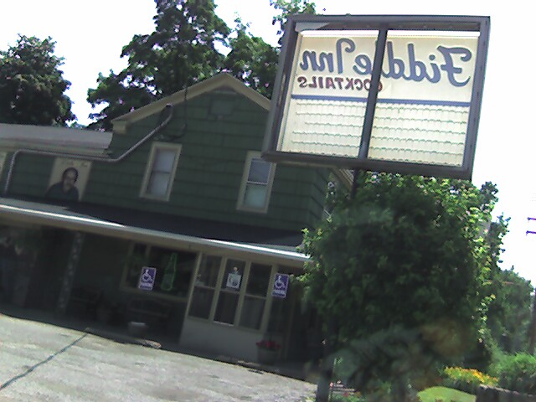
It doesn't always work out that way, but I always get a better feel for who actually lives here... and why. The photo above shows The Fiddle Inn: Cocktails, a tavern in a town somewhere near Erie, PA. You can tell from the signage that it's seen better days. The food is good, but the cook must have had to spear the fish before slapping it in my sandwich; now I won't get to Cleveland before rush hour!
As for general meditations on how well the prow of our freedom ship slices through the muddied political waters these days, especially with respect to the FSP/M:

At this point I had transcribed some reflections, but I decided to move them to a separate location out of line with the main narrative here. They're my own personal preoccupations toward motivating people via appeals to abundance and trying to get more reason into the movement. For those wanting to pursue the discussion, please go to this temp site (http://brianrwright.com/Coffee_Coaster/04_Articles/070622_Temp.htm) and check it out; the Coffee Coaster forum welcomes your feedback.

What about the Porcfest Setting?
No badmouthing the organizer(s). Rich Goldman is a righteous dude and put together a damned fine package, all things considered. Many thanks to the hardworking volunteers.
One of the advantages over previous years farther north is the proximity of Gunstock to the south—airports, population centers, etc. The lodge part of the facility is almost exactly right, plenty of space for people to mill around and talk, adequate room for large crowds on the main assembly (were that to have occurred). Vendors have very good access. And one doesn't have to travel too far into the outside world to hook up with lifestyles of the rich and famous right there in the Lake Country environs.
Virtually everything else, though, I have to honestly give mediocre to failing marks:
• We had little of the neighborhood intimacy that prevailed at the Rogers facility. It's nice to get farther away, and the northern regions are only another hour or two of travel anyway.
• The bathroom facilities were inadequate by most standards.
• We had to traverse far too many sharp-rocked, unpaved surfaces, including a two-acre parking lot, with distances that made walking impractical for the most part.
• The largest camping area, which looked like it could have accommodated all of us together was occupied by a frankly annoying Cub Scout crowd or whatever.
• Staff of the facility often seemed genuinely clueless and unconcerned with how to best accommodate the customer (apparently, Gunstock has a history of government subsidy going back to the Roosevelt era): Before leaving with my friend Don on Sunday, he had scraped and cut his lower leg quite badly by falling. We went to the check-in desk, the attendant had no awareness of first-aid facilities, no awareness of first aid, and wasn't able to provide a workaround. Don went into the restroom there, and guess what, no towels! How do you wipe up the blood of a wound with a blow dryer?
• There are several enterprising opportunities at the facility that go unexploited, such as better food, more thorough food service, better and more thorough routine supplies, a first-class bar that stays open all the time, a games room (if there is to be one) that doesn't look like a bomb shelter, other things for the kids, well, you get the picture.
• The resort sponsors several activities that appear to be performed half-heartedly—which reflects on the general feeling I have Gunstock is a resort in name only. It cries out for a thorough, not necessarily expensive, makeover.
I think we need to keep trying. My personal preference is to go back north into the White Mountains, perhaps more remote than Lancaster. If we can find a facility better than Rogers, with not much more in the way of price and having convenient access to towns, I'll be there in a Free State minute.
###
That's all I have for now. Guess it wasn't so brief. Hope you enjoyed the commentary and experience; please don't take any wild opinions or sloppy sentimentality too seriously. The main thing is to get your buns over here. Come join us this winter and again next summer. IMHO the FSP/M is still the watershed/linchpin in the modern movement toward freedom, abundance, and citizen empowerment.
Live free and flourish!

2007 July 16
Copyright © Brian Wright | The Coffee Coaster™
2007 FSP Porcupine Festival|Free State in Summer|Porc Fest

