Don't Throw Mama off the Turnpike!
The "Free State Audi A4" finds a new home abroad
by Brian Wright
The Free State Audi
Finding that perfect buyer...
Okay, here's the plan, Mom.... Mom?!
On the road again
Making the deal
Windmills? We ain't got no stinkin' windmills!
Coda

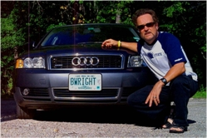
The Free State Audi...
The time had come... as times inevitably do: the car had to be sold—i.e. the world-famous Freedom Rider's Audi A4, 1.8 Liter Turbocharged, 2002, Dolphin Gray, with New Hampshire Vanity plate: BWRIGHT... as described reverently in Brian Wright's number-one best-selling[1] book on the Free State experience, New Pilgrim Chronicles...
On my way to the MVPs [Merrimack Valley Porcupines] meeting on Saturday, I’m thanking whatever gods may be for my unconquerable 2002 Audi 1.8-liter, turbocharged A4. For 70,000+ miles now it has not let me down with a single major repair need, and the new tires are real grippers. (I’m thinking the guys down at Nashua Audi may want to send me new S4 [a screamin' Audi A4] for all this free advertising. Scott? Mark?). — Page 89
Refreshing my memory now by reading key passages in the book about this marvelous automobile—I realize it's only a thing—and it dawns on me this ride of mine was a unique and exceptional encounter with the Free State:
"I drive along some terrific twisting roads, well-maintained, that most enthusiasts would pay good money to drive so routinely at will. I just died and went to highway heaven." — Page 8
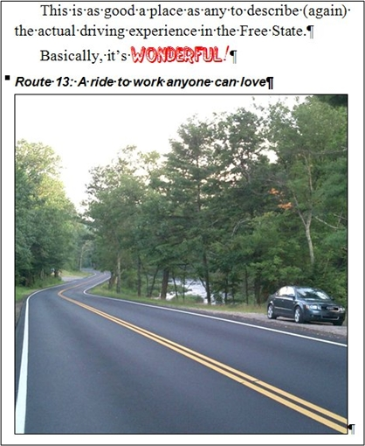
See left. — Page 33 ["One rapidly becomes accustomed to driving five to ten miles along a winding road with virtually no traffic and no traffic signals. In the town centers, speed limits are typically 30 mph, and you’re okay if you keep it five plus."]
"Also, due to my need to seek work, I didn’t drive around enough exploring in my first few months. That’s something you’ll surely enjoy doing, especially if you like performance driving. The roads are fabulous, and some roads are fabulouser than others. And they’re all within driving distance, too." — Page 132
You can see, my particular experience of the Free State has a lot to do with roads and with driving. And this particular vehicle has been my steed. An old cowboy resists the need to sell (or eat) his horse, but sometimes a man's gotta do what a man's gotta do. Fact is, the Freedom Rider's financial situation has tracked very closely with the global-imperial Goldman-Sachs/Carlyle-Group loot-and-shoot "Down with People" economic regime: the Alien Space Lizards (ASLs) and Pod People have managed to worm their way into his ability to obtain predictable, remunerative productive work.[2]

Finding that perfect buyer...
In order to pay the bills, the Freedom Rider has to be honest about what are needs and what are more in the nature of wants. As you can see from the footnote, I have been constrained as a Free State early mover to be outposted back in Michigan indefinitely for financial and personal reasons. Although the economy is bad worldwide, the economy in Michigan—location of the once-kickass Motor City—is really bad. Moreover, to sell a foreign-made automobile in the ultimate "Buy American (or else)" union-mentality state adds to the sales' challenge, and subtracts from the sale price.
By way of preparation, I secure the services of a local Novi, Michigan, off-the-books body shop... to bump out a "scratch" on the left front fender (caused by Freedom Rider pilot error in a garage-insertion maneuver). Also in Novi is a Henderson's Glass franchise to replace a cracked windshield [thanks, Mr. Rockhauler!], and, directly across the street, I engage Novi Car and Truck Boutique to perform a complete detailing (cleaning inside and out) of the vehicle. Finally, even though it's 500 miles before my next scheduled checkup, I contact Porsche-phile Jeff Jones of Automotive Techniques for one final service call. My ride is bona fide prime time sweet...
... for a 2002 Audi A4 with 129,500 miles on it. I wind up posting an advertisement in Craigslist, which is a free national want ads system, but you only get one ad per metropolitan area. I pick Detroit metro; initial returns, including spam/scam responses[3], are not encouraging. So I hit VeHix with a free online ad, and pony up something like $39.95 to get a super-wombat thunderpig listing in AutoTrader. I start the price on the hopeful side of $8300, because the VeHix site computes that comparable cars are going for $7500 to $9300. Realistically, based on the Craigslist response and Detroit-area digs, I doubt I can get more than $7000.
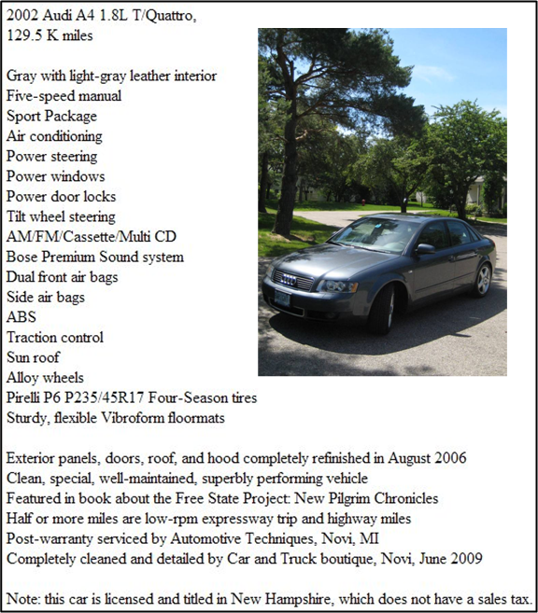
The AutoTrader.com post seems to do the trick. I receive some interest from a local man with an apparent decision-making disorder... he actually comes for a looksee and test drive, with wife and college-aged son—the intended driver—in tow. He remarks at the much better condition of my car than any he's seen. Mine's even cheaper. Next.
The second guy is an "enthusiast" (he knows every arcane detail of all Audis everywhere in history: "What collision shop in Novi did your paint job after the keying, and did you see any metal flaking appear 16.3 days following the application of the primer?"). But Guy #2 is a real buyer, and I'm confident he'll fork over $6400-minimum cash upon driving over from Grand Rapids and seeing the car tomorrow.
However, a couple of nights before chatting with Enthusiast Guy #2, I receive a phone call from a woman with a strong accent whose English is not so good:
"You have car for sale, still?"
"Yes, I have the Audi listed for $6900, and it is still available."
"It good shape, no problem?"
"That's right, Ma'am, I've had it cleaned and fixed up nice."
"My son want, maybe. Is price no move?"
"Pardon? ... well, I have to keep it at $6900 for now."
"Okay, will see. We New York, (will) call back."
"Hello? Hello?"
(I'm paraphrasing.)
I chalked the call up to possibly a spam/scam caller as discussed in the footnote[3], but she didn't seem to fit the profile. After all, how are you going to scam someone if he doesn't understand you? The next morning I receive a call from a woman with a similar accent as last night, only quite good English and a pleasing voice. She identifies herself as Mary (like those Indian customer service reps, "Mary" is not her real name).
Her sister is the one who called before. The son of her sister and brother-in-law lives in the country of Georgia—northeast of Turkey and the other side of the Black Sea from Ukraine; it is a country the United States government has not found a reason to invade, yet—, let's call him Fred. (It seems everyone from Georgia has a suffix on the last name "ashvili," which probably means 'leave us alone or we will carve you into little pieces.') Fred has perused AutoTrader.com online and found my precious wheels, apparently determining that of all the cars in all the world my little Audi A4 has his name on it. Mary conveys that she and the young man's parents live on Long Island (New York) and that Mom and Dad, for reasons that are not clear, are going to help Junior acquire such a vehicle stateside.
The $6900 price is acceptable, but two problems:
- They and I live about 1500 miles apart, and
- I still have to pay off the loan (~$3200) to get clear title
Well, we're young (er... she's young) and imaginative, so we noodle out ways for the transaction to proceed. Initially, Mary, who serves as the middleman (because Fred's Dad, aka Bob, is not too English-savvy either), tells me Bob is willing to send me a cashier's check provided I promptly pay off the title, then drive the car out to Long Island. I'm all right with that, but they must quickly figure out that, not knowing me from Adam, they would be up a creek should I take their check, keep the Audi, and get a new phone number. Plus, they would be buying sight unseen.
Next, Bob considers flying or have someone drive him to Michigan, from whence he can check out the wheels, write me a (bona fide, guaranteed-type cashier's) check, and drive back with the A4. But that falls through because he doesn't have the time and lacks a "wing man" to drive out with him. I suggest we meet half way in Syracuse, New York—when I travel between Michigan and the Free State, I often overnight at the Knights' Inn in Liverpool (a suburb). Ultimately, that's what we agree to do.
Somewhere in the middle of these negotiations thru Mary, and with consultation with some friends and family and my insurance company in New Hampshire[4], I make the decision to go with the New York Georgians. I tell Guy #2 that I'm following the money. Plus it gives me one last ride in the Freedom Coach, albeit along boring Interstates full of too many police and too few skilled drivers. Sure there's a risk, but it seems the greater risk lies on the buyer's side: after he gives me the money and takes the car, I still have to pay off my loan and send him the title.

Okay, here's the plan, Mom... Mom?!
Bob is going to leave NYC on an Amtrak train on Wednesday, July 22. I will leave Detroit area with the Audi on Tuesday, July 21, arrive at Liverpool Knights' Inn that evening after driving 500 miles, then I'll pick up Bob at the Syracuse, NY, train station at 4:01 p.m. on the 22d. Bob will have cash money for me in the agreed upon amount, along with an additional $200 for my travel expenses.
Well, our expenses, meaning for me and for whoever I can find to be my "wing man" to caravan with me to Syracuse... in order that I'll have a ride back to Michigan. [I have checked with car rental agencies and it is proving hard to locate a firm that will rent me a one-way trip. The other notion, ride-sharing back to Michigan, seems fraught with more uncertainties (I might be carrying a lot of cash) than the transaction with the Georgian "Family."] Let me think, who has the time and the wheels to follow me to Syracuse, stay there for two nights, and drive me back? Hmmm.
All right, no need for fanfare. It's got to be my 82-year-old mother, and her 1997 Mercury Villager:
My ex has a Jeep Wagoneer (ca. 2003?) and might be willing to help, but, aside from participating in a time-distance road rally together with the Audi Club—we actually had a lot of fun, except for her tossing her cookies about five minutes into the event—we don't generally find ourselves on the same psychological wavelength in ideally cooperative ventures. Most of my friends in Michigan who have cars have real jobs, so far. Same with my nephews/nieces—except for the ones toughing it out at the university, tending to their children, planning their weddings, or working overseas for the Peace Corps.
So Mom it is. It's not as if she's never had a long road trip under trying conditions with yours truly. Back in my childhood era, Dad and Mom would bravely sally forth with my brother and me in the back seat to explore the country.... like the Griswolds in Vacation. Diamond mines in Arkansas, trips to my grandma's Iowa farm, and several long weekends to the Ozarks, Missouri; we even rode in Dad's company-car Dodge sedan down to Mexico in 1957, back when the Ugly American wasn't so ugly. Tire technology was still shaky.[5] Forrest and I weren't too rough on the elders on these trips, but we certainly weren't a walk on the beach either.
More recently, Mom and her Ford Aerostar were my means for returning to Houston, Texas, after being released from the Oakland County (Michigan) Jail on my own recognizance. [This is the famed There Must Be Some Mistake story, where, because of my dalliance with indoor-growing of one or two plants of the weedy substance Bill Clinton did not inhale, the drug-law goombahs finally caught up with me... complete with extradition and walking thru Houston Intercontinental Airport in handcuffs, just like in the movies.] (Someone said my character in the book, i.e. me, reminded them of Tom Hanks!) In any case, my car and belongings were still in Houston, and Mom was kind enough to drive down with me from Michigan to help me pick 'em up.
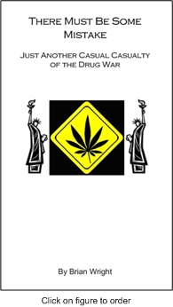
That was about 10 years ago, now, but it's one of those nostalgic events in her life that I know she likes to think of whenever she's feeling down. What excitement to have a son facing conviction on drug charges, where she gets to travel the world as valued chauffeur between two once-great all-American working-class, redneck-racist cities to help move furniture. She could have had a doctor, or a lawyer, or a businessman, or even a drywaller, for a son: seen him happily married with children in a cushy suburban neighborhood where she'd regularly get invited by the daughter-in-law to drink tea, play bridge, and dote on the grandkids.
Boring.
Here's a passage from TMBSM worthy of a Mother's Day card (it's after I've been picked up by the Houston police on an arrest warrant—that I had no idea was ever issued—then carted down to the Harris County Jail, where I stay for Seven Days in Summer):
"This is a collect call from the Harris County Jail… (subliminally implying “from a nefarious criminal.” To accept the charges, press *"
Mom hardly expects to get a call from the jail, and she has no clue of the particular incident back in Michigan behind all this. But she has long been dimly aware of my political notions and of my antipathy toward the state in general. So eventually figuring out the key to push, she picks up on the second call, imagining it could at least be a friend of mine.
"Hi, Mom. Well, geez, you're not going to believe this, but ..."
Really depressing. I'm telling her the circumstances that led to my confinement, then I try to remember some telephone numbers for people I had planned to be visiting up there in three days.
Poor Mom. This can't be easy for her either. She's back in Michigan and 72 years old, trying to get all the instructions right, press the right keys, talk to the right people, etc. Worrying about me.
"No, Mom, it doesn't really seem dangerous in here or anything. Just boring and noisy. I get to watch a lot of TV, particularly all those black sitcoms I missed the first time. Everyone seems to get along all right."
I know she misses the thrill of the road, plus she's still in pretty good driving shape, until very recently motoring the Villager by herself across the state of Michigan to Battle Creek to visit her sister every month or so. So I break the news to her gently: "Hey, Mom, let's take a ride to western New York, we can see those windmills southeast of Buffalo area. It's a short trip [mumble mumble '500 miles']."
Eventually, it comes out that I need her to be my wing man for completing the sale of the Audi. She's actually elated that I'll finally be out from under that $500-a-month expense, so she's inclined to say yes. Yet I do sense some waffling: "Can't you get a friend, or (ex-wife) Grzelda, or what about (nephew) Bart; you went on a couple of road rallies with him before." I assure her that I've thought everything out carefully—fact is, I'm running out of time on the validity of my NH registration, and have to act quickly without considering a lot of bona fide wing-man alternatives—, "the trip is all turnpike, mostly light traffic, piece o' cake, just point and set the cruise control."
"But I don't know how to use the cruise control," she demurs.
"It's easy, Mom, I'll show you. Plus I'll get walkie talkies."
"Walkie talkies?"
"Right, it's like having a CB, you press the key on a mike."
"I'm not sure I have the strength."
"Aw, Mom, be a trooper."
"Oh, fudge," I hear under her breath. But she concedes that it's the best alternative for overall success of the jury-rigged household financial system we find ourselves in. Then I tell her, "On the way back, after we see the windmills, we can stop at the Professional Football Hall of Fame in Canton, Ohio, where you can stare at the bust of your hero, Troy Aikman."
"Big whoop," she says.
Just a word about my relationship with Mom: I know it's not cool or even desirable, as an adult person (especially of my advanced years), to be living with one's parents. But with the economy the way it is, I'm sure there are a few other Baby Boomers out there who have moved back with Mom and/or Pop—though technically, in my case, Mom is living with me, not the other way around. [Heck, by sharing the rent it makes it easier for you to compete with your folks for the MacDonald's openings after GM terminates their pensions.]
But my point is while we love each other like family, we have a certain conversational style that drives me batty. For example, I'll be explaining the discoveries of Pete Hendrickson relative to the federal so-called income tax—namely, that the law is explicit making the so-called income tax an indirect tax on federal privilege... in other words, it most certainly does not apply to normal earnings from our livelihoods—and she'll come back with, "Yes, I see what you mean: those Chinese are really inscrutable." So while I've been known to ruin her day with excessive ranting, she gets back at me as Queen Noir of the Non Sequitur.
I'm hoping on the trip, which may present some bona fide major-league challenges, that we can practice restraint of our more exasperating tendencies in order to get the job done.

On the road again...
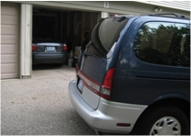
On the morning of the 22nd, we get up and on the road at the crack of 10:00: early rising and lightly, quickly packing have never been my strong suits. But I'm glad I remembered to take the camera, so I can get a photo record of sending my ride off to another land and to the next, perhaps, ultimate owner. According to the ancient Chinese saying, "A journey of a thousand miles begins with carefully backing out of the garage."
Naturally, I'm taking the lead in the Audi, and considering how Mom will be reacting to the grueling nature of big-city driving that—fortunately or unfortunately—she's been spared from for several months. Amazing how we urban drivers take for granted the rigors of entering multiple-lane expressways negotiating exit-only lanes and double-trailered umpty-ump wheelers climbing up our asses at 75 mph. The initial entrance is the worst, Eight Mile Road onto Interstate 275. Damn. Poor Mom; I forget she isn't driving an A4... and that her reflexes are 82 years old!
Later I learn that that 8-Mile entrance was a rude beginning, that Mom felt she was going to be sideswiped by a truck, and was saved at the last minute by another truck who saw her plight and decelerated to let her enter. Such knightly behavior by lords of the road would be repeated within a couple of hours after a crucial misstep at the toll booths leading to the Ohio Turnpike (I-80/I-90). It could have been a showstopper, this misstep.
We continue from the western Detroit suburbs down I-275, then onto I-75 in Monroe County, crossing into Ohio, then a few miles south of the border taking a left on I-280 through eastern Toledo over the new, spectacular Veterans' Glass City Skyway bridge spanning the mighty Maumee River. It's a beautiful day, and traffic isn't bad; we do manage to exchange a few words over the walkie talkies, like when she comes back, "You stinker: I can't press this key down, talk in the mike, watch the road, get the air conditioner to work, and answer questions about where I packed the potato chips or did I see that hawk on the left. Enough already the silly chatter."
Potential showstopper:
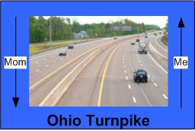
We come to the toll booths from I-280 leading to the Ohio Turnpike. It's kind of a screwy setup as all traffic entering the turnpike, whether heading east toward Cleveland (where we're supposed to go) or west toward Chicago, lines up in the same bank of booths. The heavy traffic flow moves me to the far left slot, and I can see Mom doing her best to stay behind me. At that point, out of the blue, this other car inserts itself between us; as I receive my ticket and drive slowly away I can't see Mom in the rearview anymore.
Worse, I see the entrance to Cleveland-Eastbound is way the heck to the right, across, what, six lanes of traffic, maybe more! Yikes! I do my best to hold up and move slowly toward the right, but I'm being pushed by traffic to get out of the way, to keep moving. Finally, that dingbat who snuck in between us gets his ticket and eventually Mom's Villager saunters out the gate. "Over here, Mom! Over here! We have to go to Cleveland!" I'm sure she can see me, but what is she doing?! "Damn, woman, get out of that lane to Chicago. Look over here! Follow me." At this point I'm talking out loud, yelling, actually.
Well, the goose is cooked. She takes the Chicago entrance. Bye bye, Mama Bear. I haven't had time to use the walkie talkie during these post-toll-booth maneuvers. But after she heads toward Chicago, I pull off to the shoulder on the eastbound side, grab the walkie talkie and start screaming—well, raising my voice a lot—saying, "Mom, you're going the wrong way. You needed to go east, not west." I know she's going to be out of range within a few minutes. Frantically, I must have said, "Take the next exit you come to, then turn around and meet me at the first service island you come to. Do you hear me?! The first service island eastbound." I hear something muffled from her, then nothing. I don't know if she heard me.
Fortunately, the first service island eastbound is less than five miles from where I entered. I pull in and walk inside where the restrooms and concessions are located. As I walk in, I pull out my Blackberry (cellphone) planning to call Mom on her mobile number. "What's this?! Oh, no, you blockhead. (...I say to myself.) You total fucking idiot: you never entered Mom's cellphone number in your Blackberry!!!!!" What do I do now?
[In the back of my mind it occurs to me that for all my recent appeals for spiritual growth and inner peace, I am not handling this situation particularly well.]
So the next step is to find Mom's cell number. Okay, who else might have it? The ex and Mom's sister, Clara. First I dial Zelda in Okemos, "Babe, you have to help me find Mom's cell number. Did I ever give it to you? It's an emergency; I've lost her at the first entrance to the turnpike." No dice. Then I call my aunt, but she's not in. I leave a message and give my cell phone number; later I learn Clara, who's no spring chicken herself and has been having memory problems of late, comes back and tries to dial my number but misses it by a digit.
Next stop, Verizon.

I can go back into my phone log and find where I was dialed by a Phyllis Wright that isn't our home land-line number. Sometimes, when she's gone grocery shopping, she will take her cellphone and call me to come out and help her bring the bags in. Finally, Verizon Guy answers the *611. Listen, Guy, here's the deal... I want him to go to my phone log, and I'll give him the password. No dice. Against company policy. Which means I'll have to access the logs through MyVerizon.com from my Blackberry, which is a major pain in the ass. I'm majorly stuck, not even sure Mom packed her cellphone or has it turned on.
I've begun to calm down a little bit. But I'm going over in my mind possible scenarios. Will Mom get off the turnpike and head back home? Does she have her cellphone? I hope she doesn't get run over by a truck. She's probably scared out of her mind. I'm kicking myself for putting her through all this; this is so bad. Should I stay here, should I wait for an hour and then head back? Geez, what did people do before cellphones? Maybe I should have joined AAA back in 1975 when I first got married.
Then just as I'm considering the pros and cons of disemboweling myself, I hear this faint ring from the Blackberry. Lo and behold and Hallelujah Baby! I've seen the number on the screen before, and, for sure, that's Mama Bear. Yes. Maybe the mission won't have to be scrapped. I answer the call. She says, "I'm at a service area." Wow, I'm thinking, maybe she's at this one. She says she's out by some gas pumps, but she'll go see if the attendant knows the name. I rise and walk out the door toward the gas pumps, and sure enough, some little ol' lady is walking from a beatup 1997 blue Villager over to the payment window with a cellphone in her hand.
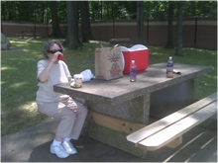
Yes! Maybe there is a God.
I'm so relieved I feel giddy. Catastrophe averted. The next eight hours, however, still prove to be a considerable challenge for both of us... with occasional comic relief. At the toll booth exiting the Ohio Turnpike, I'm getting my change, when Mom during a moment of inattention, or simply being overtasked, lets the Villager thump my rear bumper. Geez, Mom. You gotta stop for physical objects. I move over to the side and park, examining any damage... nothing obvious. Then on the other side of Cleveland, we stop for lunch at a rest area. Here's Mom grabbing some much deserved nourishment ... along with a double-shot of Jack Daniels.
We're a lot more relaxed now having made it through the maze along Highway 2/I-90 through the heart of Cleveland and put that supposed-rejuvenated city 40 miles behind us. Time for some discussion, a little post mortem. We acknowledge that Mom "made a fundamental directional error;" note, she did not "f**k up." The circumstances were unusual, and "Son #1 was unprepared for an emergency." He, of course, did not "f**k up" either. I say, "Okay, Mom, it's all behind us now. Just remember as 'wing man,' you have to stay glued to the leader. Right on my tail, no matter what the maneuver."
The stretch of E-way around Erie, Pa., I've driven many times, and I've tried probably all the different exits for services, none of them being first class. Today is no exception. [Erie, the city, sits on the south shore of the big Great Lake of the same name; the I-90 E-way is a strip of concrete perhaps 10 miles away from the shoreline and proceeds northeast toward Buffalo, New York. There's actually a wonderful view of Lake Erie on many parts of the highway: somehow the angles of the surfaces make the lake appear as a mountain range over the region.] I manage to avoid the "Megamall-Sprawl" outlet, and pull off at the last-chance "Beverly Hillbillies" exit.
After two half-blind turns across traffic flow, I see the gas station is a dilapidated Speedway, next to a Hot 'n' Now fast-food franchise. It's started to drizzle, and feels like a whole lotta wet comin'. The A4 looks as out of place here as a "quiche guy in a barbecue town." The place is busy, and I only see one filling slot available; it will work for a vehicle having its filler on the driver's side (the Villager) but not for my Audi, which fills on the passenger side.
Aha, I think, I'll drive through the one remaining opening and Mom will follow me, then she'll know to stop at the pump, and I'll just park by the store and gas up the Audi in a few minutes.
So I roll through the slot, no time for walkie talkie, pointing for Mom's benefit through my rear window toward the gas pumps. Then I continue, making a loop and park in front of the convenience store. I look up to my right, and there's Mom in the Villager parking beside me. Sigh. I rest my head on the steering wheel. She took me literally about staying glued to my butt, and followed me all the way around to where we are now. What a display of driving teamwork! Wonder what Jethro and Ellie Mae are thinking.
Now that's comic relief.
It's about 4:00. We're a little more than halfway to our destination, but still not through Buffalo. Sure enough, the rains do start. We get one squall somewhere between the end of the first tollway and the beginning of the second, smack in the middle of rush hour. Visibility isn't so good, but Mom is staying reasonably close behind, fatigued I'm sure. I try to stay in touch with the walkie talkie, but Mom still hasn't got the hang of it.[6] Then on the final 120 miles of boring tollway, traffic is light enough, smooth sailing except for intersecting about three monsoons in succession. The Audi is all right with it, but the minivan is outside of specifications for sure; Mama manages to stay in sight of my taillights and resists the urge to pull off. To put the finale on our day of driving dread, for about 10 miles immediately west of our destination, the Turnpike Authority is completely replacing the eastbound lanes, and we're treated to a massive construction jones.
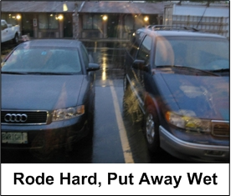
We made it. Another one for the record books, and another set of experiences for Mom's journals—she's been keeping logs, complete with pictures and poetry, of mainly family affairs and her own experiences in life and work since 1982—that she won't soon forget. We get the two-kingsizers' room with microwave, fridge, Wifi, and sonic toilet. She crashes quickly on her bed, while I stay up working my site and the next world-liberation book—with HBO flickering soundlessly in the corner of my eye and a big helping of Maker's Mark disappearing rapidly down the ol' gullet —before caving in on mine.

Making the deal
As generally miserable and laborious as the ride over has been, and as awful as the weather, Wednesday—"Free State Audi" D(eal) Day—turns out to be one perfect wind-at-your-back, sun-on-your-shoulders kind of day. It reminds me of waking up in La Jolla, California, in the late-1970s, on this business trip from hell, where our flights are bounced one after the other, we're sleeping in plastic airport furniture, and don't get to the motel until 0500. Walking to the rental car from the room—approximately 0900—I glimpse the ocean, feel a light, cool breeze on a cloudless 65-degree day. The colors are so deep, the sky so blue, everything so perfect, I comment to the boss, "Paradise. Now that's some kinda wakeup call!"
Okay, so Syracuse, New York, isn't La Jolla, CA. But compared to yesterday, I am totally cooking with gas today insofar as the weather goes. I don't have to pick Bob up from the station until 4:01, so I have plenty of time to clean up my baby one last time. Then around 11:00 a.m. Mom and I drive the Villager to discover the marvelous city of Syracuse, New York. The objective is three-fold: to find how to get to the train station (which turns out to be only three miles from the motel), to locate a Citizens' Bank branch that will be open for exchange and deposit of an uncomfortable amount of cash, and to get the lay of the land, figure out what makes Syracuse Syracuse.
It turns out Syracuse has historically served as a gateway city for the country of New York, apparently a crossroads between the Erie Canal and its branch canals and the intersection of several overland roadways. One thing unmentioned in the Wikipedia article is that—with Electronics Parkway (on which our nice suburban motel resides), a strong Lockheed-Martin presence, and Syracuse University—there is a substantial tie-in to the city from the American-government war and high-spook machinery.
Anyway, as in most NY towns, the people are still human—the majority just as nice and warm as you'll find anywhere else in America—but more worn down by the space lizards and pod people (SLaPPs) [7] after decades of trying to live up to the "Empire State" designation. As I mentioned in my New Pilgrim Chronicles experience traveling through Massachusetts, there's a strong correlation between high taxes (Mass and NY have a sales tax approaching 10%, an income tax of that magnitude, too) and dead businesses and the foundational loss of enterprising spirit.
But the history of Syracuse must be fascinating. As we're driving around trying to locate the entrance to the train station for later reference, I note that we're in an old manufacturing district of town. Back in the day—not all that long ago either, maybe the 1950s and 1960s—your major-industry shipping was accomplished by rail. Virtually all plants that produced heavy equipment, machinery, and even those that processed agricultural products, relied on trains to move their output down to the next tier of supply. And here we are today right in the middle of the industrial manufacturing and shipping section just five or six decades ago: I can see the grass growing over the old railway sidings where freight cars were loaded before moving to the main track and attached to the locomotives.
What killed the railroads for freight? You got a couple of minutes? Basically, the same thing that killed the railroads for passengers: economic distortion caused by government interference in the market... in this case in favor of King Automobile (and its many political welfare cases). I don't want to get too far away from my story here, but the simple act of removing these distortions to allow rail to compete with trucking and Interstates would save trillions of gallons of fuel and dollars, tens of thousands of jobs, and mitigate a major source of global pollution/warming.
Here's an interesting sight. Several of the one-way roads, in the city of Syracuse proper, angle the automotive parking such that you're pointed in the direction of the one-way traffic. I hadn't seen this before. It implies a different technique for parking, and I wonder if it's included on the standard state driving test. Obviously, you drive slightly past the parking spot then back into it.
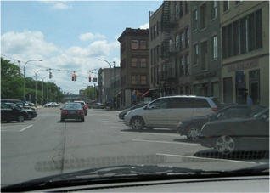
The moment of truth is fast approaching. I drive Mama back to the motel, then perform a final checkout of areas I'm concerned about in the overall presentation of the car. I have talked with Bob, and have his cellphone number; his English is passable but he probably won't be winning any Shakespeare sonnet contests in the near future. He seems like a straight shooter, and Mary assures me that he's a great driver with more than 10 years experience in the New York City and Long Island environments. I've informed her that I feel we have a solid deal now, and at this point I don't want to have to dicker on the price; she assures me that won't happen.
Another concern I have is that hundreds of "Federal Security Lugnuts with Badges and Guns" are infesting virtually every transportation channel these days. Here's a guy carrying upwards of $5,000, and there has to be some stupid law against that; if they stop Bob for any reason, his English probably won't be good enough to uphold the Constitution (like a Cross vs. Dracula) to stop the bastards from stealing the dough. A number of incidents have been reported recently where federal TSA, Homeland Security, and Immigration pukes have assaulted and detained individuals without even any suspicion of wrongdoing. The ultimate police state grows while we watch silently (and while search-engine giants like Google appear to filter out large numbers of such stories—solely an intuition at this point).
Getting way ahead of myself, and worrying about a future that may never come. A waste! Where's my Eckhart Tolle-ism when I need it? I arrive with my baby at the train station well before 4:01, and what a refreshing experience! There's small sign of the aforementioned police state. You can walk around, talk to people, look suspicious, and nobody pokes you in the ribs or wants to empty your pockets. I park for free with ample door-ding free space on all sides. The (Amtrak) train station sports a bus depot on the other side. The pace is leisurely, even languid. And friendly. I notice several instances of apparent strangers in the waiting area striking up conversations with one another.
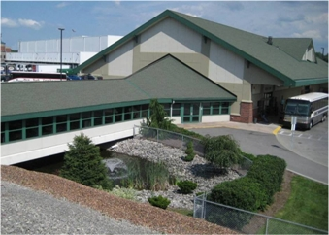
Then suddenly in a remarkably good mood, I walk around snapping several pictures—the architecture is interesting and the landscaping appropriate—and I stop at the ticket window, basically shooting the breeze with the attendant, a 20-something amiable black man. We must have talked about ten minutes about trains, rates, the business end of the process, even a little industrial history. I have to remind myself that this fellow has no experience of routine travel on passenger trains when they didn't need government subsidies... as when my brother and I rode the train from Kansas City to Chicago, by ourselves, 50-some years ago.
Bob's train from NY City is running about half an hour late, which 20-Something Train-Guy is kind enough to update me on with a description of the problem. Finally, the train rolls into the station and I meet the man. As Mary has told me, his English is all right... he simply isn't much of a talker. I can tell he's righteous dude, knows cars, and wants to get the transaction taken care of as soon as possible. The bank branch where I want to conduct the exchange is a few miles away in a shopping center.
I'm doing the driving until I get dropped off back at the motel: one last time I get to feel the driving of this unique, precious, genuine automobile, shifting down while matching engine and transmission speeds, accelerating into curves, applying the brakes. Bye-bye, girl. In the bank-branch shopping-center parking lot, I ask if Bob has any questions or wants to see the service records. I mention that I've had the car professionally cleaned, including the engine:
"Here, let me show you the engine."
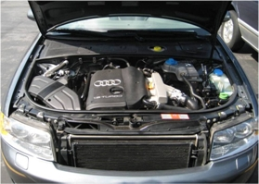
Bob waves me off, his gesture suggesting he believes "everything I've ever said, or thought, or done" relative to this car... and that he wants to TCOB (take care of business) and head back to Long Island. I say, "Look, Bob, I'm showing you the doggone engine bay; it's a thing of beauty and you need to appreciate this. Okay?" And that's that. Afterward, we walk in to the Citizens' Bank branch where I've already prepped the manager that we'd be dropping by. Bob hands me an envelope full of hundreds, I hand him a signed bill of sale, then purchase a cashier's check to pay off the lien, deposit most of the remaining cash into my account... and we're outathere.
I guess a lot of things were exceptional about conducting this transaction, but I think I caught the perfect buyer, at the perfect time, for the perfect car. Mind you, with 130,000 miles under its belt, various subsystems start to go south at unpredictable times. The previous nine months or so, I've replaced a thermostat assembly and an ignition-related subassembly. Typically you're looking at $300-$500 per subassembly, plus labor. It ain't cheap.
Problem is, especially on modern performance and luxury cars, you can't simply replace a seal or a thermocouple and ride on. No sir. You have to buy the entire assembly and snake your way in—like Tom Cruise in Mission Impossible—to swapping the old one out and the new one in. I hope Fred, Bob's son, the ultimate recipient of the Free State Audi, keeps track of its precious bodily fluids religiously and has an honest, knowledgeable German-car mechanic on speed dial. [Don't forget the next timing-belt replacement; I recommend it at 175,000 miles to be safe.]
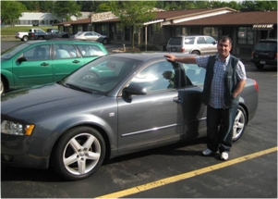
That's it. I drop off myself off at the motel, make sure Bob gets all the records and the little doodahs—like emergency keys and touchup paint, that I've assembled for him. Before he rides on, I ask him to pause for a photo-op. I'll consider the sense of loss later, but for now I feel a major weight has been lifted from my shoulders. I insert the cashier's check into a Fedex envelope and drop the envelope in a Fedex box as I take Mom out for a sit-down dinner at the Colorado Mine Company restaurant. Good premium beer call: Saranac Black Forest.

Windmills? Windmills? We ain't got no stinkin' windmills!
The return days should be fun. What I had in mind was to drop down from the turnpike at Rochester then scoot southwestward through the foothill country along state and county highways. From a trip back from the Free State a year or two ago—in the A4, hubba hubba—I remember some excellent twisties, then coming up on mountain pass after mountain pass of wind turbines (wind mills): the large 200-foot-tall ones that rotate slowly and supposedly cause problems to birds and bats... and now, I understand, human property rights.
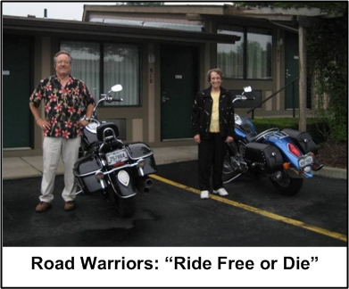
First a little color commentary on a transportation alternative I had in mind if the Audi deal went awry. I would just turn the car in for cash, rob a bank or both, then head down to the Harley dealership and pick out a couple of real machines... like these pictured in the motel parking lot. Actually, I believe these are Victory motorcycles, driven individually by a boy/girl team who arrived later the previous night. Anyway, with a couple of helmets, some leathers, sensible shoes, and a riding lesson for Mom, we'd get back to Michigan in style. [I suppose I need to lose the Salvation Army Hawaiian shirt, too.]
So the plan is: windmill sightings today, Pro Football Hall of Fame tomorrow, with return to Michigan five hours after that. Today is a drive day, and if any experience is designed to make me miss the Audi, it's driving through rural countryside, in the hills, on state and county roads with plenty of twists and turns... and enough straights to let out the engine. And boy did that A4 engine purr: as I announced in one of my ads, "the engine is so sweet I seldom even turn on the premium Bose eight-speaker sound system."
Sure enough, I find myself off the beaten path without a DeLorme (detailed road map mainly for performance-driving enthusiasts), with my mom who really isn't that excited about winding remote roads that occasionally run out of pavement. I keep forgetting that getting lost in a Mercury Villager is nowhere near the fun of wandering around creatively in the Audi. Oddly enough, though, I'm feeling comfortable in retirement from the fast lane. Some light rain visits us as we work our way through the region consisting of wide open valleys for farming and rounded 2,000 ft. mountains for resort snow-skiing. Occasional towns pepper the path, some with more charm than others; enjoying a quiet light lunch from the cooler with Mama Bear makes me grateful to be exactly where and when I am.
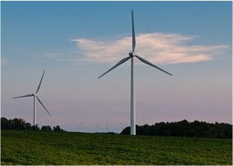
Unfortunately, we miss the windmills. I keep saying, "I know they're in this general vicinity; this town really looks familiar." I probably am off 25 miles south, and it never does occur to me that in the motel last night I could have WiFi-ed up a complete layout of the Western New York Wind Turbine Farms Galore. But nooo! That would have meant thinking ahead and leaving nothing to chance. Well, one of these days. Anyway, let me supply a photo of the type of wind turbine that is available—in New York and in several other states, including Michigan (especially in the Thumb area)—for your viewing pleasure.
I've associated a link with that windmill photo, which describes some political and even some technical issues with the wind turbine projects that have been implemented. Naively, I had assumed, when first seeing these wind farms two years ago, that they were "energy for the people and by the people." Apparently, at least a significant share of the projects have been "energy foisted on the people" from afar... by Nobel Environmental, a consortium with majority ownership of JP Morgan Partners headquartered in Connecticut. Property rights and human rights are routinely trampled and health effects ignored; significant opposition is emerging, much of it from environmentalists. Looks like a good story.
Maybe we missed the windmills because they've been taken down.
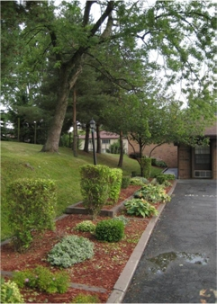
Onward. We manage to avoid the NY turnpike entirely, then stay off the main Interstates in northeastern Ohio, which is as boring and flat as a Kansas wheatfield. We arrive at a little town east of Canton and check into a Super8, which seems a little high at $69—even with my good-looking guy discount—but the Holiday Inn I'm told charges $109. Plus it's after 7:00, and there appears to be a decent old-fashioned family restaurant right next door. Plus, check out the landscaping; for a Super8 no less!
[Turns out the food and service at this restaurant is fine, but it seems to have a large TV beaming down noise and video from every other booth... all turned to FOX. Yeccch! There goes the appetite. We've definitely landed in middle-America McCain-Palin territory (less-literate freedom-crushers)... vs. the Obama-Biden types (slightly more-literate freedom crushers). Oh well, the prices are good and so is the food. Thank you very much. And we're back in the morning.]
On to the Pro Football Hall of Fame. I'd been there once before after an Audi Club rally, with my nephew, in southern Ohio. What's the significance of the Hall? Well, I've grown to be a minor National Football League (NFL) junky, largely thru the dissipative activity of Fantasy Football Nation, but also from an appreciation of the sport from pee wee to the pros. In regard to the youthful game, both Mom and I are huge fans of the miniseries about Texas high-school football, Friday Night Lights. Plus, from Mom's years living and working in Texas, she became a Dallas Cowboy fan—particularly the halcyon years of the 1990s with the dynamic trio of Troy Aikman (QB), Emmitt Smith (RB), and Michael Irvin (WR)... all inductees in the Hall (Emmitt is a shoe-in during his first year of eligibility in 2010).
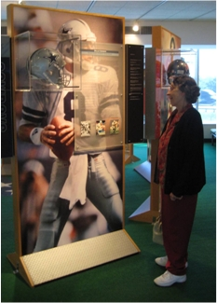
Mom is especially fond of Troy Aikman, whom she regards as the most eminent ambassador of the sport and the consumate gentleman-warrior. I agree. Not only is he one of the greatest quarterbacks of all time, he's one of the most credible and informative NFL football-game announcer/commentators to come along, like, ever... even if he does work for FOX. [Actually, FOX, unlike its so-called political reporting, has some of the most competent and professional personnel covering football.] So here we are in the part of the Hall where each NFL team has a pedestal with a representative player-icon. Here’s a photo of Troy and Mom doing a Cowboy mind meld.
As we draw our visit to a close, I reflect that this institution has done as well as any in avoiding the corporate wretched excess that characterizes most enterprises in the media eye, especially sports concerns. The Hall is a non-profit organization funded by voluntary contributions; in the presence of a multibillion-dollar industry, it retains the look and feel of your local YMCA. Even the gift shop is relatively modest; we decide to buy one of the least expensive items, a couple of shot glasses bearing the emblem of the Dallas Cowboys. That purchase finally seals it for me: after the Detroit Lions go 0-16 in 2008 (and as inclined as I am as a Free Stater toward the New England Patriots), I am now officially making the Dallas Cowboys my all-time team.
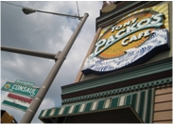
That's it for the trip. Except for the stopoff on the south bank of the Maumee for an early supper at world-famous Tony Packo's... home of Jamie Farr's (Corporal Max Klinger in M*A*S*H) designated source for Hungarian cuisine. Just about every celebrity who ever lived has a signed hot-dog bun on the wall of the restaurant, and Packo's makes the best stuffed cabbage aside from my former mother-in-law's.
As it seems we're being processed particularly urgently today—get 'em in, get 'em out—I make a point of slowing down my responses to the waitress. I also eat—and drink my crafted beer—more deliberately. I make an observation to Mom that we seem to face many unconscious forces in life wanting us to hurry, to be anxious about the future or nervous about the past, rather than to take our time and stay in the moment.
By golly this moment, every moment, belongs to us.
[But I do have $500 in my travel bag in the car, so let's finish up.]

Coda
Many years ago, I owned a custom Yosemite-Sam-built 1967 Harley Sportster, that was simply beautiful, but impractical to use as a commuter vehicle while attending Wayne State University. So I sold it. Got a good price, too. I was sad, playing the slow movement of Rachmaninoff's famous Second Piano Concerto with a tear in my beer as I watched the buyer ride away on it.
I'm older now, and it was time to move on. No tears. I heard back from Mary that her nephew was caught on video with a look of pure elation on his face that his folks had consummated the transaction. That's enough for me. Fred, please know that the Audi you drive will forever have the pedigree of the hallowed ground of the Free State embedded in its molecules. Ride on, friend, and may the freedom of the open road inspire you and your countrymen as well.
###

[1] Based on latest household sales figures for Free State-inspired literature purchased by my mother, my ex-wife, and my favorite barmaid.
[2] Basically, the problem was I came to the Free State without having a job in hand, naively thinking finding work there would be routine. I have a small condo in SE Michigan—mortgaged considerably higher than what can get for it—that my mother rents from me. She needs more care than an absentee landlord can provide, plus without work, I can't pay the mortgage without her rent. And I definitely can't afford to pay for lodging in two places. Hence, this is why I'm not physically present in NH on a continuing basis.
On top of the corporate-megaleechatarium facing any (now-60-year-old) American man, yours truly is also an increasingly public, radical human-liberation advocate who has no doubt been black-balled in many quarters... having defied the state sufficiently to be accorded a felony drug record. (It's a great, entertaining all-American story, and I hope you will find time to (buy and) read/review There Must Be Some Mistake. Thank you in advance. [If I sell enough books—TMBSM, New Pilgrim Chronicles, and the Sacred Nonaggression Principle—then in the immortal words of Arnold Schwarzenegger, "I'll be back."])
[3] A word about scams in the "on-your-own" automobile sales business: apparently the biggest scam is giving a seller a bogus cashier's check and driving away with the car. More sophisticated are the firms who will provide—for a fee, part of which is refundable—to you a "large number" of buyers who will pay your asking price. [So I guess these buyers don't read AutoTrader?]
[4] My legal residence remains the Free State, and the Audi is registered and insured there; I'm holding on to my Free State driver's license until they pry it out of my cold, dead fingers... or until I no longer authorize the state to license me to travel.
[5] Just as girls back in the day learned how to cook a satisfactory family meal, a major rite of passage for post-WW2 middle class boys in the Hinterland was learning from the old man how to change out a flat tire with a spare. (Brings to mind a scene from A Christmas Story where Ralphie helps his dad with the process, scatters the lug nuts... and blurts out a cuss word.) Tires in those days went flat if you rolled over a large insect.
[6] The toll for the first stretch of I-90 from the border into Buffalo is $3.00. I learn later that Mom gave the attendant a $20 and got back $2.00. Welcome to New York: "Give me your tired, your poor, and your elderly... and we'll fleece 'em like true professionals." ...low-life piece of camel dung.
[7] A theory I have developed over the last year or two identifies the chief threat to humanity (and its corresponding natural nonaggression principle) as what amounts to a psychological defect, possibly of genetic origin, in an extremely small number of biological humans. This defect regards the (surreptitious yet massive) initiation of force or theft upon other human beings as wholly desirable; I have called the politically efficacious humanoids with this defect Kleptocons. [Recently, I am naming the aggression-inclination that afflicts them the "Alien Space-Lizard (ASL) Syndrome."]

2009 August 10
Copyright © Brian Wright | The Coffee Coaster™
Free State Audi | Georgia Country | Pro Football Hall of Fame | Brian Wright

